**Enterprise Resource Planning**

*Of*

**ZAB**

**Training User Manual**

**VERSION 12.0.0**

**Purchase**

**Index**

|  |  |
| --- | --- |
| **About** | **Page No.** |
| * Purchase Order | **03** |
| * Create GRN | **05** |
| * GRN Modify | **09** |
| * IMPORT LC ENTRY | **11** |
|  |  |

# purchase ORDER

* Purchase Order Header

|  |  |
| --- | --- |
| **Step 1** | Main Menu (Home Icon) **> Purchase & Procurement >** PurchaseOrder |
| **Step 2** | Enter Supplier ID () and choose purchase type, Payment term, Currency, Date etc. |
| **Step 3** | Click **Add** |
| **Result** | PO will be created. |

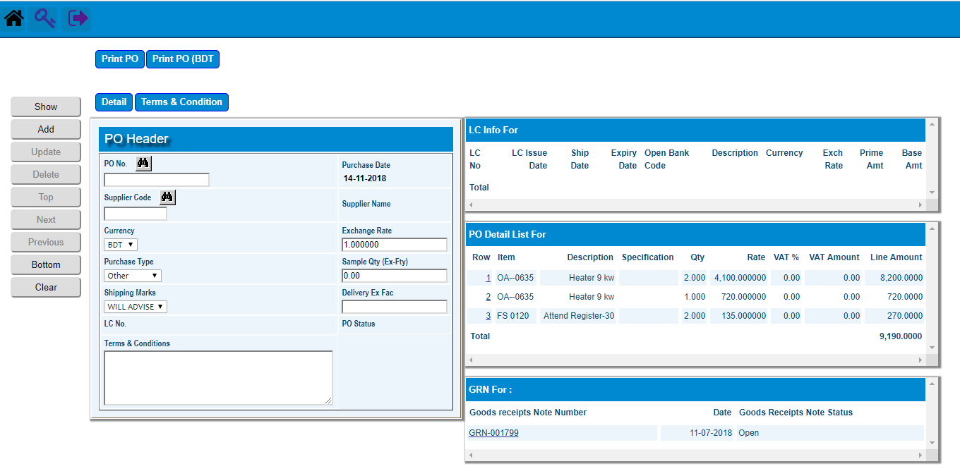

* Purchase Order Detail

|  |  |
| --- | --- |
| **Step 1** | Click Detail |
| **Step 2** | Select the desired item by clicking on the item code from the side list & write qty & price |
| **Step 3** | Click **Add** |
| **Step 4** | Repeat Step 2 and 3 for adding multiple products |
| **Step 5** | Click Complete when done |
| **Result** | PO created. |

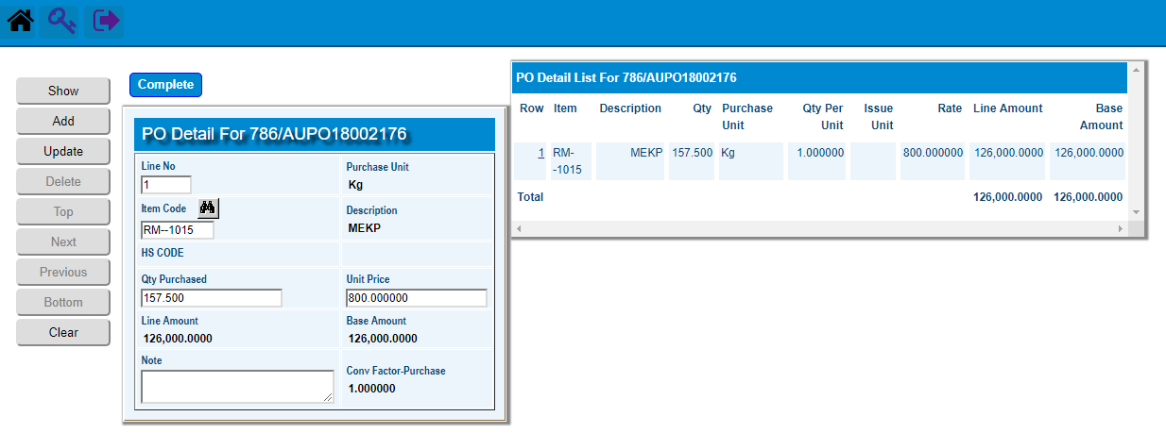

|  |  |
| --- | --- |
| **Step 1** | Click **Confirm** of PO Header |
| **Step 2** | The Created PO will be Confirmed |

# Create GRn

* Create GRN

|  |  |
| --- | --- |
| **Step 1** | Main Menu (Home Icon) **> Purchase & Procurement >** Create GRN |
| **Step 2** | Choose A Purchase Order No to Create GRN |
| **Step 3** | Click **Create GRN button** |
| **Result** | GRN will be created. |

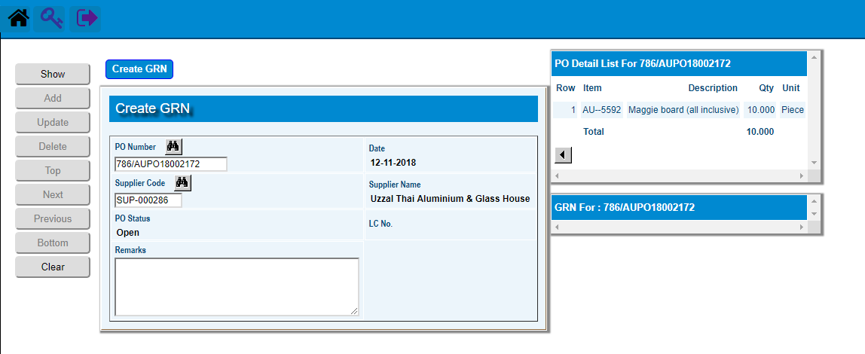

** Pick the created GRN to go GRN Header

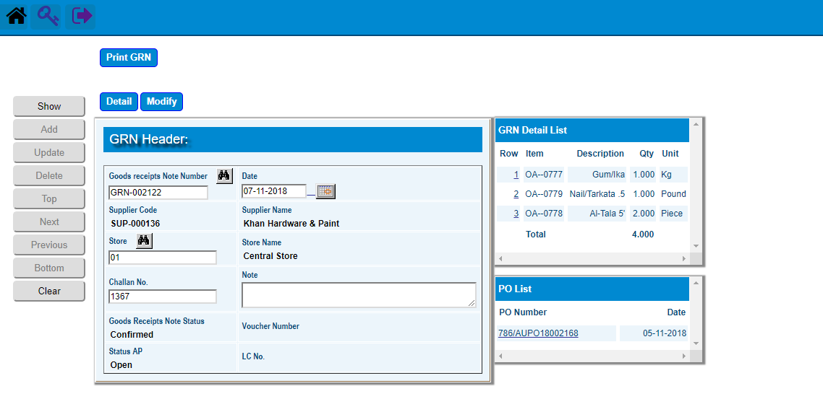

**) Click **Detail** for GRN detail and then Click **Return** to return GRN Header

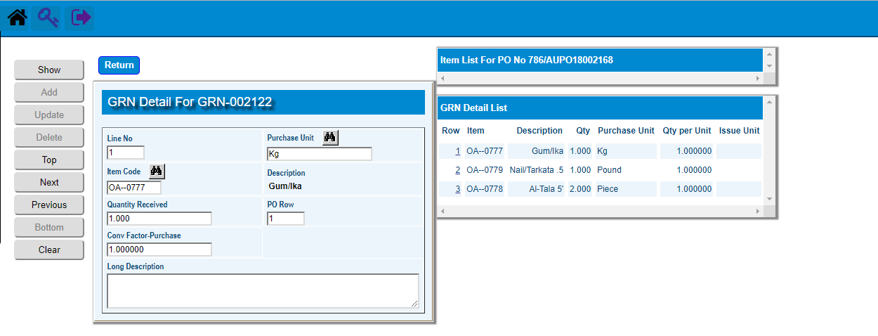

**\*\*)** Click **Confirm** to Confirmthe GRN

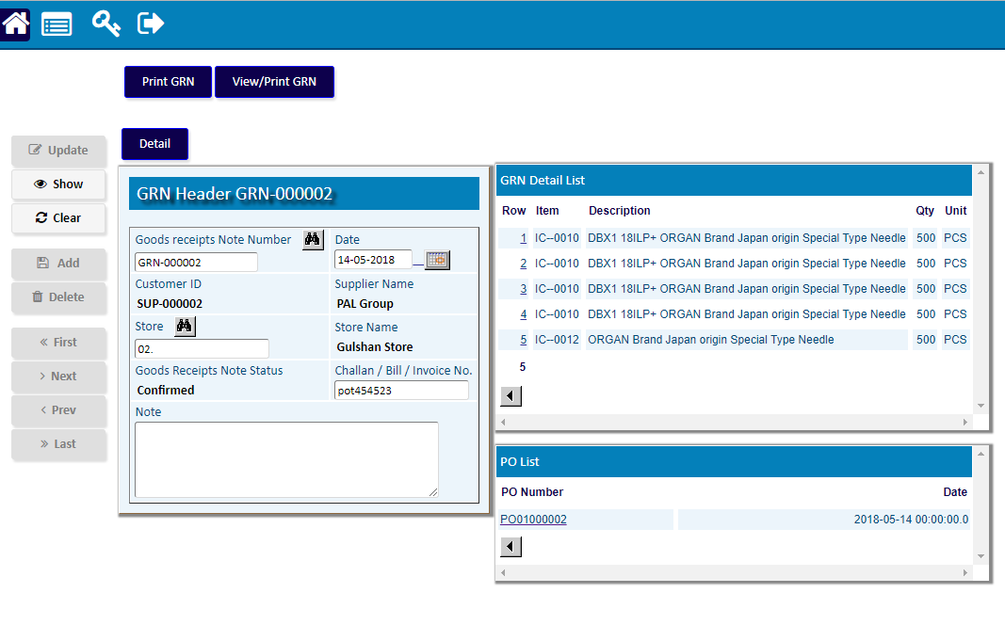

# GRn Modify

|  |  |
| --- | --- |
| **Step 1** | Main Menu (Home Icon) **> Purchase & Procurement >** GRN Modify |
| **Step 2** | Choose the GRN number to Modify and Click **Show** |
| **Step 3** | Click **Detail** for desired Modification of GRN products |
| **Step 3** | Click **Return** and then Click **Confirm** for Modification Confirmation |
| **Result** | GRN will be Modified. |

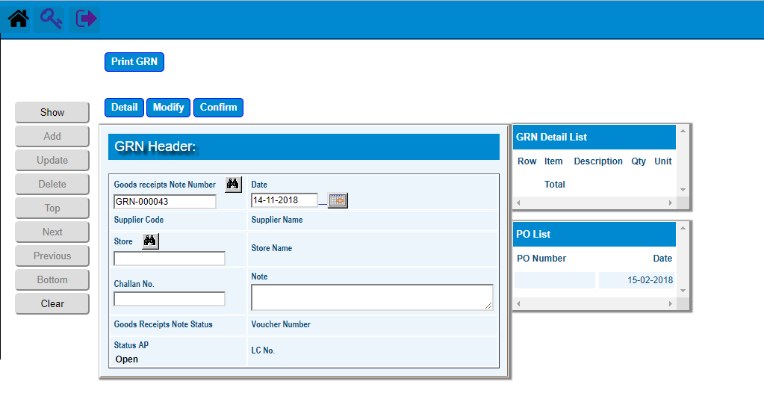

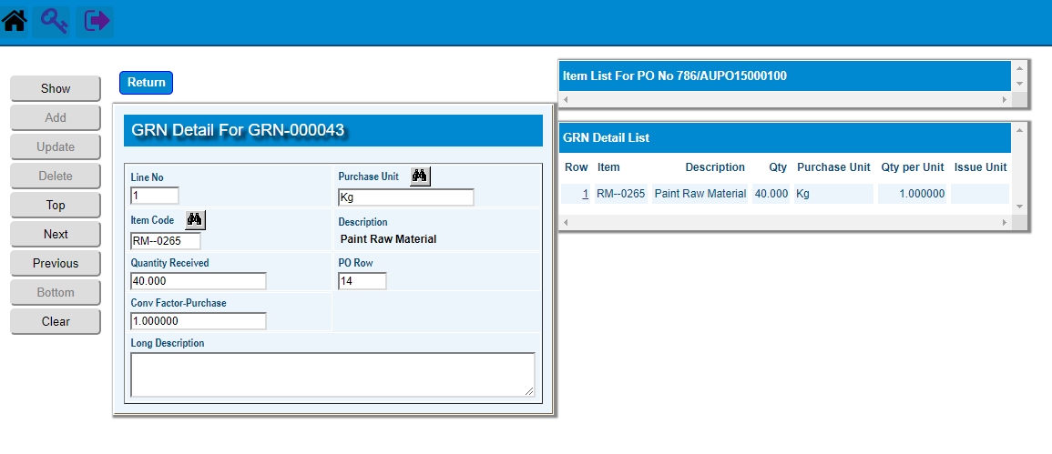

* **Import LC Entry**
  + IMPORT LC ENTRY

|  |  |
| --- | --- |
| **Step 1** | Main Menu (Home Icon) **> Purchase & Procurement >**  IMPORT LC ENTRY |
| **Step 2** | choose LC type, Date, Reference, PO number etc. |
| **Step 3** | Click **Add** |
| **Step 3** | Click **Detail** for Product Detail of PO (against the **LC**) |
| **Step 3** | Click **Amendment** button to add LC Amendments |
| **Result** | A new LC of the PO will be created. |

